**Final Project – Airlines**

**Morgan Kelehar - ITC 295:001**

This database tracks specific flight information. It starts out with a ticket that will keep track of the customer, flight number, departure airport, and the arrival airport. Additionally, the flight will keep track of the departure and arrival airports, the employees working, and other important information. This information will help the airlines keep track of the different elements that go into a flight and ensure consistency and clarity of information between them and the customers. These simple ERD diagrams can be expanded upon to add entities for the company, specific planes, seat numbers, and more.

**ERD – Level 0**

**ERD – LEVEL 1**

**ERD – LEVEL 2**

**CUSTOMERS**

INSERT INTO mk_customers (customer_id, password, first_name, last_name, phone_number, email, address, city, state, zip_code) VALUES ('BA17283959', 'WildTacos20', 'Brian', 'Alderman', '8164481263', 'brianalderman@gmail.com', '1110 N Highway Ave', 'Kansas City', 'MO', '64151');

**AIRPORT**

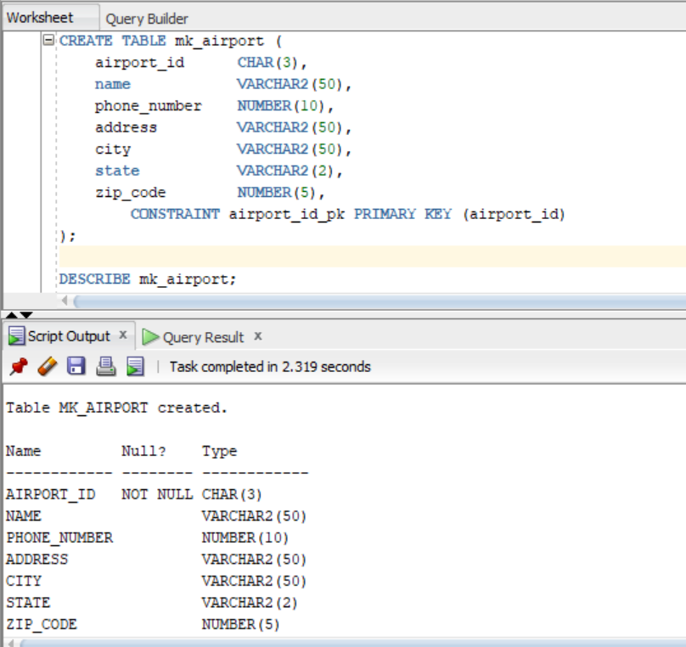

INSERT INTO mk_airport (airport_id, name, phone_number, address, city, state, zip_code) VALUES ('MCI', 'Kansas City International Airport', '8162435237', '1 Kansas City Blvd', 'Kansas City', 'MO', '64153');

**FLIGHT**

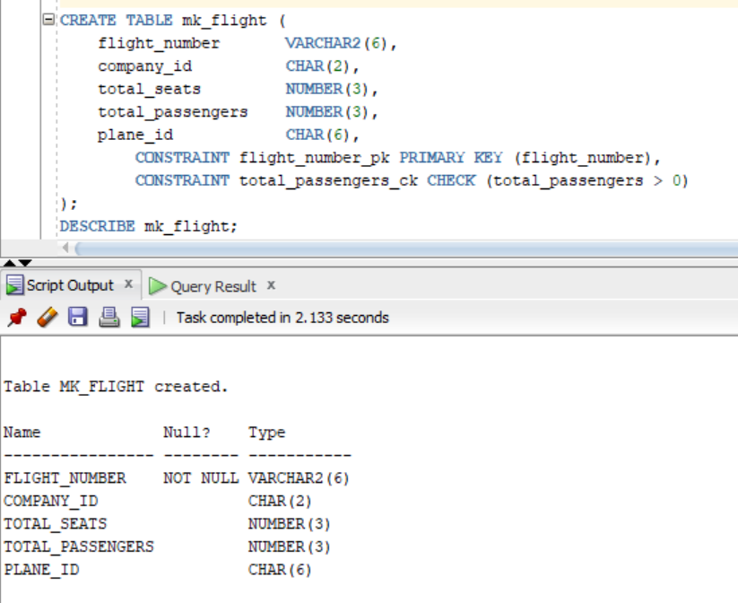

INSERT INTO mk_flight (flight_number, company_id, total_seats, total_passengers, plane_id) VALUES ('WN1736', 'SW', 143, 126, 'N8539V');

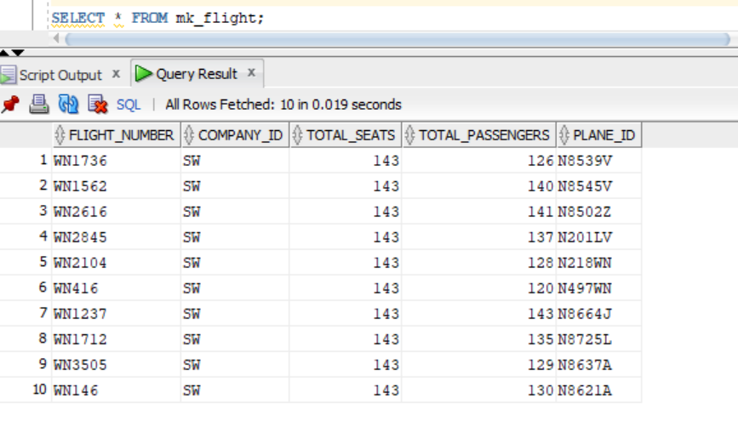

**EMPLOYEE**

INSERT INTO mk_employee (employee_id, password, first_name, last_name, position_title, phone_number, email, start_date) VALUES ('JC85438906', 'IlikePlan3s!', 'Janet', 'Conner', 'First Officer', '8173245678', 'janetconner@gmail.com', '08-FEB-2005');

**EMPLOYEE DETAILS**

INSERT INTO mk_employee_details (flight_number, employee_id, position_title) VALUES ('WN1736', 'MB68300791', 'Captain');

**TICKET**

INSERT INTO mk_ticket (ticket_id, customer_id, flight_number, first_name, last_name, seat_number, gate_number, depart_airport_id, arriv_airport_id) VALUES ('GM43F', 'BA17283959', 'WN1736', 'Brian', 'Alderman', '17B', 'A28', 'MCI', 'TPA');

**Query with a JOIN**

**Filter in WHERE clause**

**GROUP BY**

**ORDER BY**

**5th Query**

